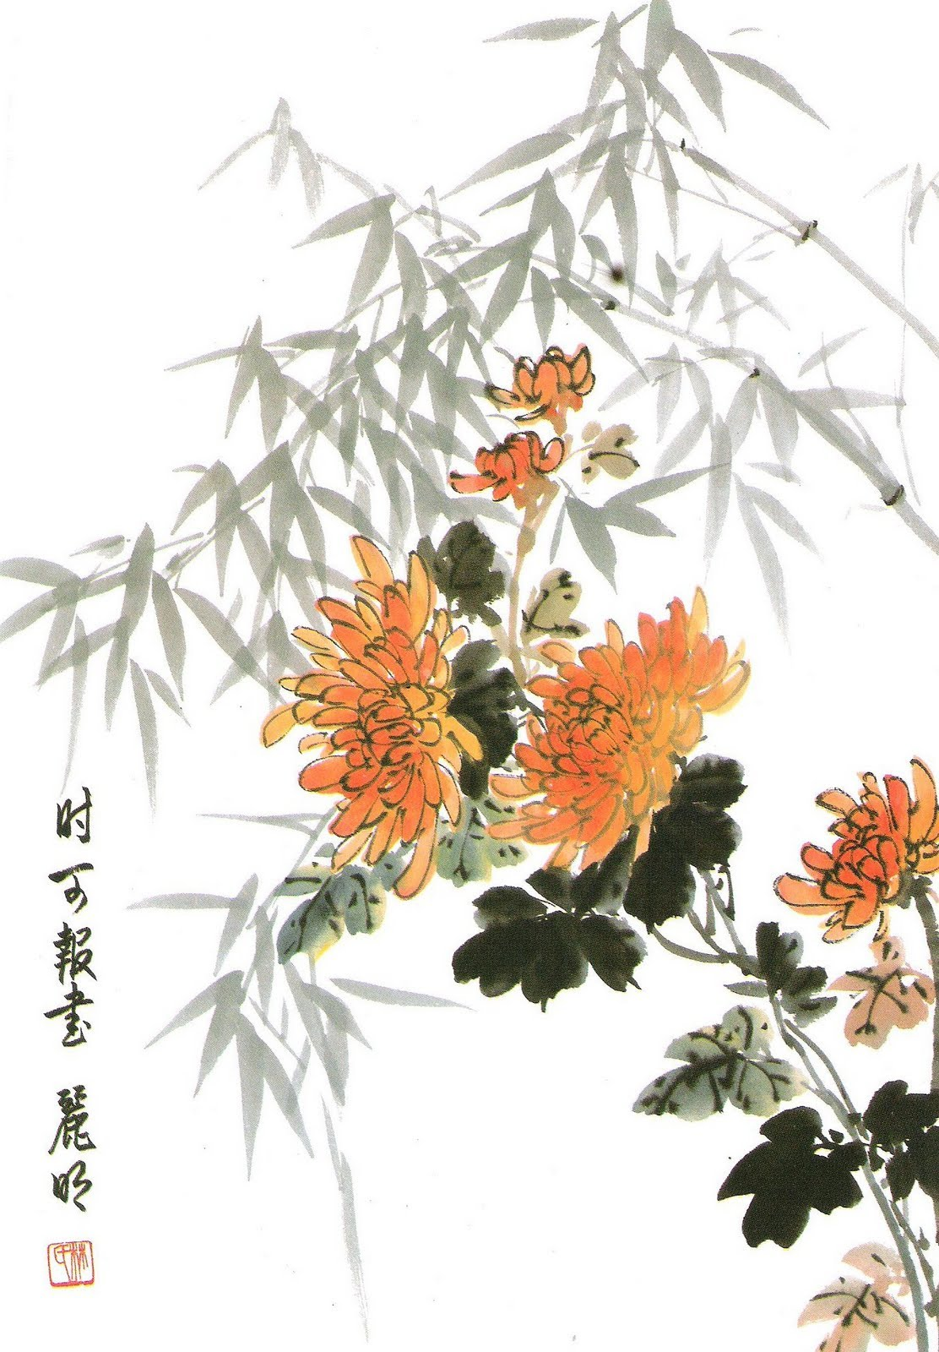
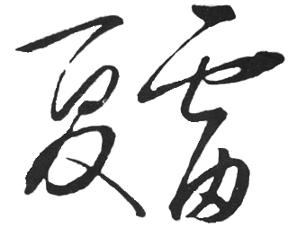

The Seasons of China

April 9, 2011
Summer Thunder Chinese Music Ensemble
“The Seasons of China" brings together beautiful traditional music celebrating the changing seasons, love of nature, and joy of festivals throughout the Chinese year.
Summer Thunder began in 2005 at the University of Arizona as the Asian Music Club with Paul Amiel as director and Dr. Janet Sturman as faculty advisor. In 2009 the group became independent of the University under the direction of Andrew Wilt. Summer Thunder has held over 60 performances in concert halls, festivals, libraries, markets, and the Rogue Theatre, bringing the beautiful sounds of traditional Chinese music to Tucson and Southern Arizona.
Special Thanks to:
The Rogue Theatre
The spouses and family of Summer Thunder for taking care of the Thunderbolts while we rehearse and perform. (Lin Yuxiang, Xu Wei, and Jan Rasmussen.)
www.summerthundermusic.com
- Jin She Kuang Wu (金蛇狂舞) – The Crazy Dance of the Golden Snake
- Chun Hui Qu (春晖曲) – Spring Dawn
- Huan Le Ge (欢乐歌) – Song of Happiness
- Chun Jiang Hua Yue Ye (春江花月夜) – Spring Blossoms on a Moonlit River
- Zi Zhu Diao (紫竹调) – Purple Bamboo Melody
Spring
Summer
- Jun Zi Lan (君子兰) – The Bush Lily
- Su Di Man Bu (苏堤漫步) – Strolling Along the West Lake
- Yao Zu Wu Qu (瑶族舞曲) – The Folk Dances of the Yao People
- Sai Ma (赛马) – Horse Race
Intermission
Autumn
- Gu Xiang Qing (故乡情) – Emotions of A Hometown
- Gu Xiang Xing (故乡行) – Walking Around Your Hometown
- Xiao He Tang Shui (小河淌水) – The Small Murmuring River
- Yu Fu Rong (玉芙蓉) – The Jade Hibiscus
- Jing Diao (京调) – Beijing Melody
Winter
- Yi Zhi Mei (一枝梅) – The Flowering Branch of a Plum Tree
- Gan Hui (赶会) – Going to the Temple Festival

Summer Thunder Members
Paul Amiel – Di Zi - Paul's love for music, Chinese culture, and talking to people led to the formation of the Asian Music Club. Paul spent 4 months in China studying the Gu Qin with master Cheng Gong Liang. He spent one year in Japan where he studied shakuhachi with Katsutoshi Ida. Paul now plays in the Japanese duo Muso, plays Turkish, Middle Eastern, and Medieval music, and performs with the Rogue Theatre. Joined 10/10/2005
Julie Trujillo – Zhong Ruan - Julie is a student studying Music and Equine Assisted Learning. She plays oboe as well as classical guitar besides her first love, the Zhong Ruan. Joined 1/15/2006.
Ping Zhou – Yang Qin - Ping is an alumni from the University of Arizona with a Ph.D. in Optical Science. She studied Yang Qin as a young girl in China and enjoys the chance to play it again, taking a break from the intellectual Optical Sciences. Joined 11/1/2005
Peiqin Cao – Pi Pa - Peiqin learned Pipa at 7 years old and then stopped playing it when going to medical school to be a physician. Recently, she truly enjoyed picking it up again to play with Summer Thunder music group. Music has been a life-long interest. She is also a member of Tucson Sino Choir. Joined 1/15/2010.
Cindy Behmer – Percussion - Cindy has studied Western classical music from a young age and is now a professional oboist and English hornist with the Tucson Symphony Orchestra. She was introduced to Musics from the around the world as an undergraduate music major and now enjoys having the fantastic opportunity to perform with Summer Thunder as percussionist. Joined 10/15/2010.
Andrew Wilt – Er hu - His interest in Chinese music came about from his college studies on the Chinese culture and his previous background in playing the violin. While teaching English in China, he studied the erhu as well as the Gu Zheng. He now enjoys playing in the music club as an outlet that is different from Computer Science. Joined 10/10/2005.
Yi Chen – Vocals – Yi is a wonderful singer and brings much authenticity to the songs she sings as she studied Chinese language and literature in China, and Chinese Liguistics and pedagogy at the U of A. Joined 1/15/2006
Yan Ma – Gu Zheng - Ma Yan studied fine art in China, and began to study the Gu Zheng as an adult. She is mostly self-taught but occasionally grabs a lesson when a teacher is around. Joined 10/10/2005.

